Lazy loading

**LAZY LOADING**

1. DELAYING LOADING OF RELATED DATA UNTIL SPECIFICALLY REQUESTED.
2. NAVIGATION PROPERTY SHOULD BE DEFINED AS PUBLIC & VIRTUAL.
3. DEFAULT PHENOMENON.
4. WHEN USING POCO ENTITY TYPES,LAZY LOADING IS ACHIEVED BY CREATING INSTANCE OF THE DERIVED PROXY TYPES AND OVERRIDIG VIRTUAL PROPERTIES.

**POCO ENTITIES->CITY.CS & DEPTLOC.CS**

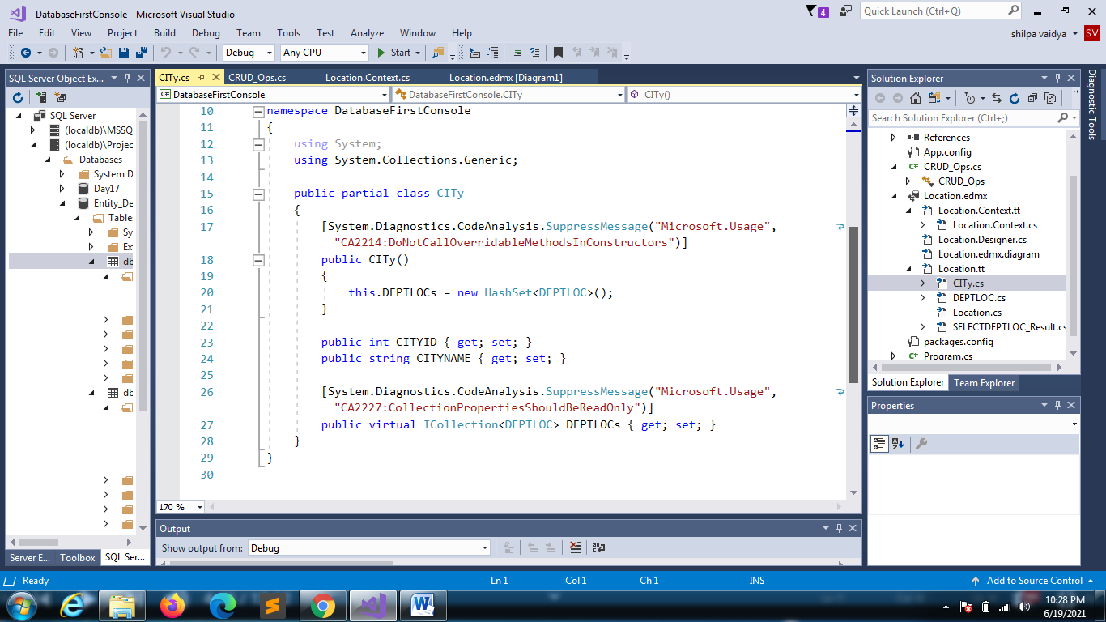

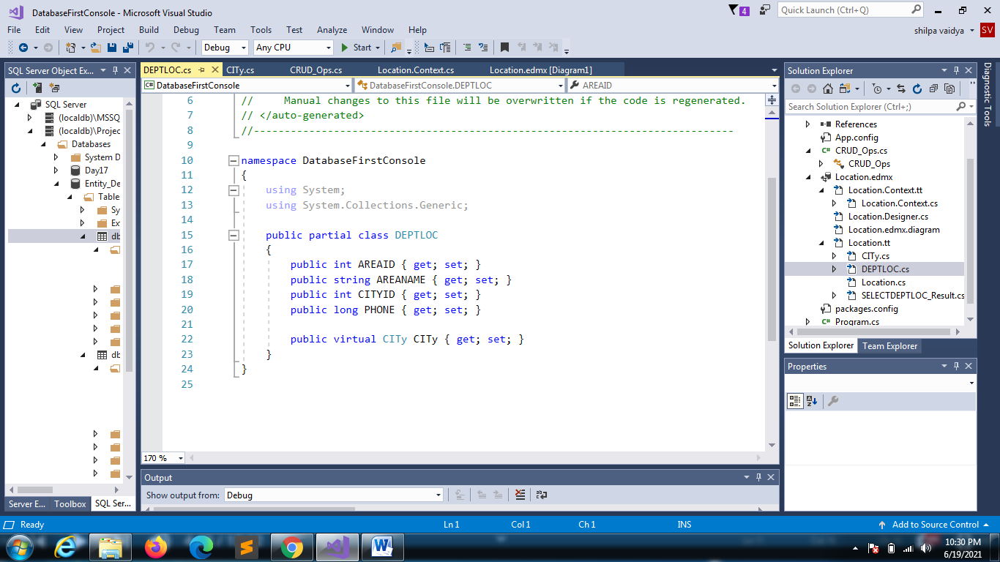

using System;

using System.Collections.Generic;

using System.Linq;

using System.Text;

using System.Threading.Tasks;

namespace DatabaseFirstConsole

{

class Lazyloading

{

static void Main(string[] args)

{

MyDbEntities db = new MyDbEntities();

foreach(CITy cobj in db.CITIES)

{

Console.WriteLine("{0}\t\t\t {1}",cobj.CITYID,cobj.CITYNAME);

foreach(DEPTLOC aobj in cobj.DEPTLOCs)

{

Console.WriteLine(aobj.AREANAME);

}

}

}

}

}

**Set lazyloading as program to run**

